AWS Secrets Manager

2. AWS Secrets Manager
2.1 Overview
AWS Secrets Manager securely stores, retrieves, and rotates secrets such as database credentials, API keys, and tokens.

2.2 Use Cases
• Store database credentials securely
• Rotate RDS credentials automatically
• Manage API keys and tokens
• Eliminate hardcoded secrets in code
• Centralized secret access across services
• Secure CI/CD pipeline credentials

2.3 Architecture Flow
- Secret stored securely in Secrets Manager
- Secret encrypted using AWS KMS
- Application requests secret via IAM role
- Secrets Manager validates IAM permissions
- Secret returned securely at runtime
Application → IAM Role → Secrets Manager → KMS → Secret

2.4 Execution Steps
Step 1: Store a Secret
- Go to AWS Console → Secrets Manager
- Click Store a new secret
- Select secret type (Credentials / Key-Value)
- Enter secret values (username/password)
- Choose KMS key (default or custom)
- Name the secret (example: prod/db/credentials)

Step 2: Configure IAM Access
Attach policy to application role:
{
"Effect": "Allow",
"Action": "secretsmanager:GetSecretValue",
"Resource": "arn:aws:secretsmanager:*:*:secret:prod/db/*"
}

Step 3: Retrieve Secret in Application
• Use AWS SDK (Python, Java, Node.js)
• Fetch secret at runtime
• Do not store secrets in code or environment files

Step 4: Enable Automatic Rotation (Optional)
- Select secret → Enable rotation
- Choose rotation schedule
- Use AWS provided Lambda or custom Lambda
- Secret is rotated without downtime

2.5 Best Practices
• Use Customer Managed Keys for sensitive workloads
• Enable automatic rotation wherever possible
• Grant least-privilege IAM permissions
• Never hardcode secrets
• Monitor usage with CloudTrail and CloudWatch
• Separate secrets per environment (dev, staging, prod)

2.6 Conclusion
AWS Secrets Manager together provide a strong security foundation for encryption, credential management, compliance, and secure application design in AWS environments.

TASKS ON AWS SECRETS MANAGER
Task 1: Store Database Credentials in Secrets Manager
Objective
Securely store database username and password so they are not hardcoded in applications or configuration files.
Step 1: Open Secrets Manager
- AWS Console → Secrets Manager
- Click Store a new secret
Step 2: Choose Secret Type
- Select Other type of secret
- Add key-value pairs:
  - username → testuser
  - password → Test@123
Step 3: Choose Encryption
• Keep Default AWS KMS key
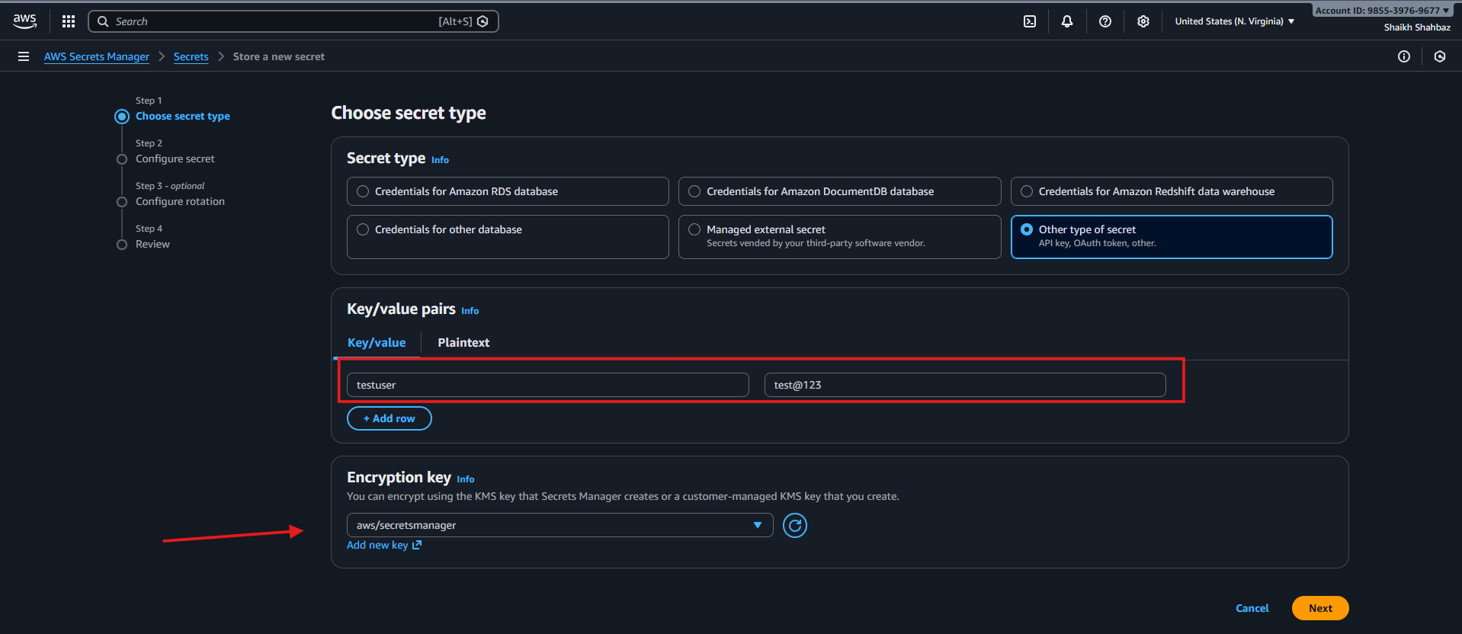
Step 4: Name the Secret
test/app/credentials
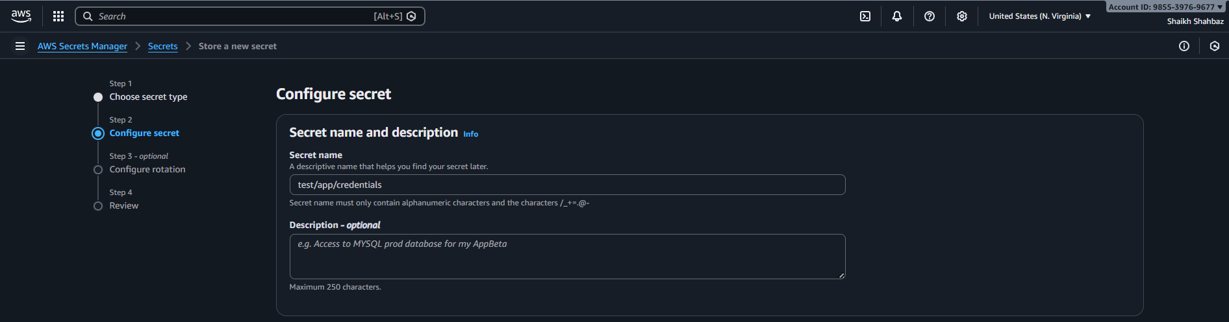
Step 5: Save Secret
• Click Next → Store
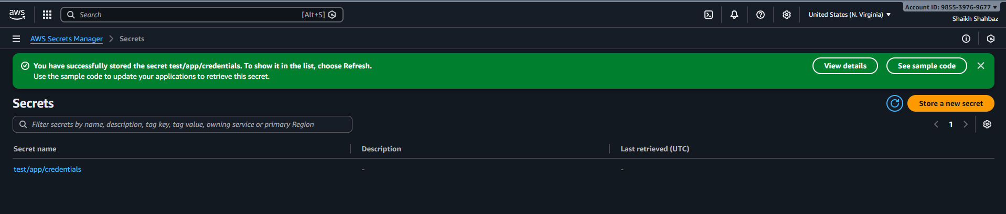
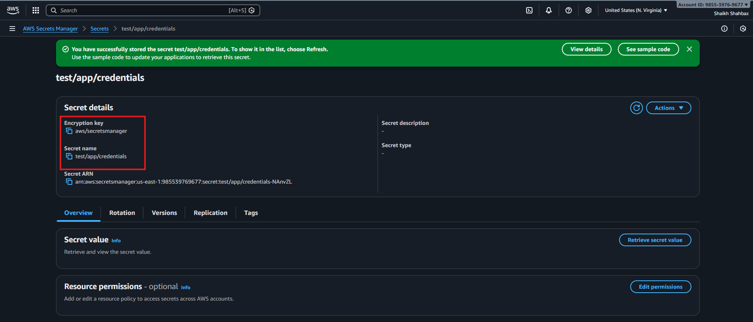
Conclusion:
Database credentials are securely stored in AWS Secrets Manager, eliminating hardcoding and reducing the risk of credential exposure. This enables centralized, encrypted, and controlled access to sensitive information across applications.

Task 2: Retrieve Secrets in an EC2 Application
Objective
Access secrets securely at runtime without hardcoding.
Prerequisites
• EC2 Instance
• IAM Role attached to EC2
Execution Steps
Step 1: Create IAM Policy
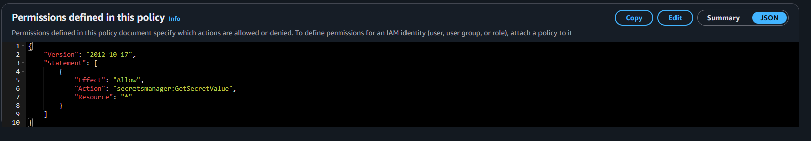

Step 2: Attach Policy
• Attach policy to EC2 IAM Role
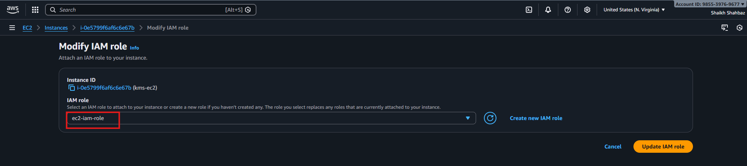
Step 3: Retrieve Secret
• Use AWS CLI or SDK:
aws secretsmanager get-secret-value --secret-id prod/db/credentials
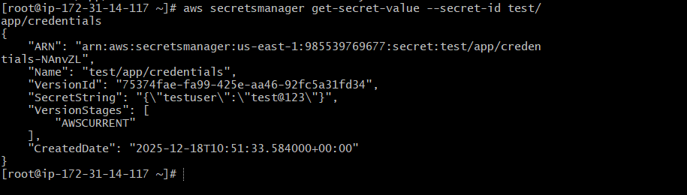
Conclusion:
The EC2 application securely retrieves secrets at runtime using an attached IAM role, avoiding hardcoded credentials. This approach ensures improved security, easy secret rotation.

Task 3: Update and Rotate a Secret Manually in AWS Secrets Manager
Objective
Manually update (rotate) a secret value in AWS Secrets Manager and verify that applications always retrieve the latest secret.
Prerequisites
• AWS Secrets Manager
• Existing secret (test/app/credentials)
• EC2 instance with IAM role
Step-by-Step Execution
Step 1: Open Existing Secret
- Go to AWS Console → Secrets Manager
- Click on your secret:
- test/app/credentials
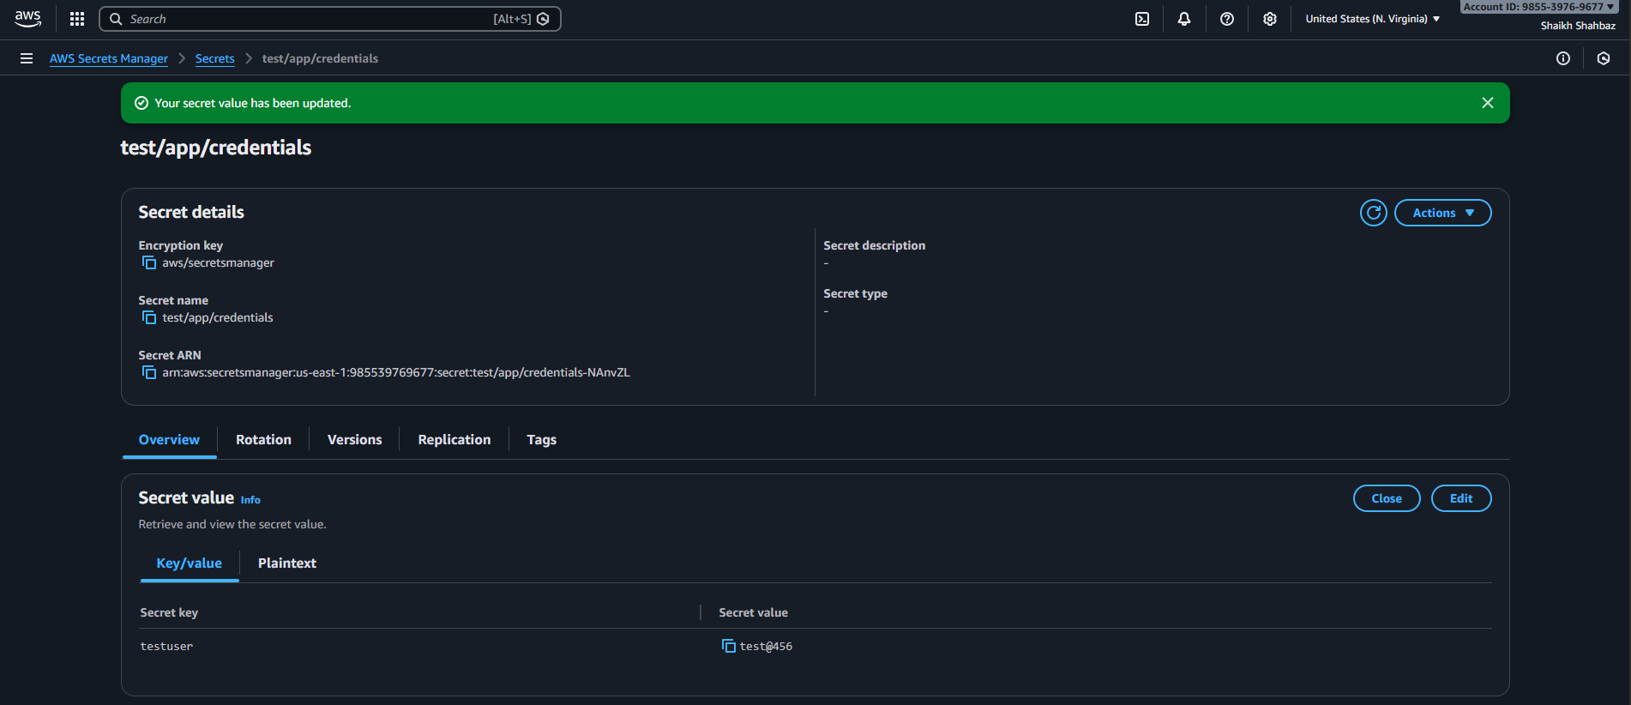
Step 2: Update Secret Value (Manual Rotation)
- Click Retrieve secret value
- Click Edit
- Change the value
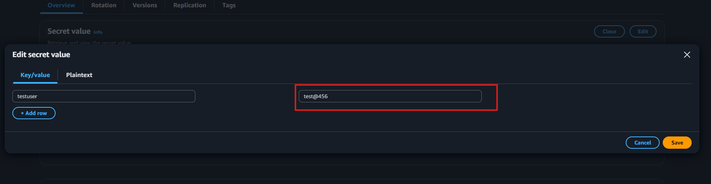
Before
{
"testuser": "test@123"
}
After
{
"testuser": "test@456"
}
- Click Save
Step 3: Verify New Secret Version
- Scroll to Version history
- Confirm:
  - New VersionId
  - Stage = AWSCURRENT
  - Old version = AWSPREVIOUS
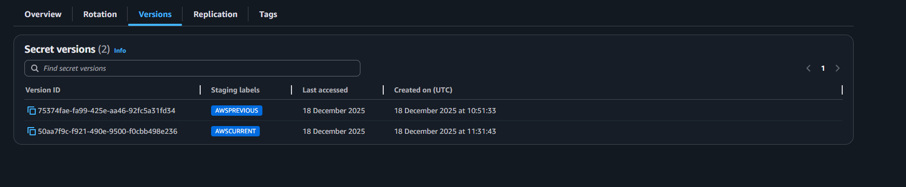
Step 4: Retrieve Updated Secret from EC2
SSH into EC2 and run:
aws secretsmanager get-secret-value \
--secret-id test/app/credentials \
--query SecretString --output text
You will see the updated value
No app restart required
Conclusion:
Manually updating a secret in AWS Secrets Manager creates a new encrypted version while preserving previous versions for rollback. Applications dynamically fetch the latest secret value at runtime, ensuring secure updates without downtime.

